The Government PU college, Rajanakunte  
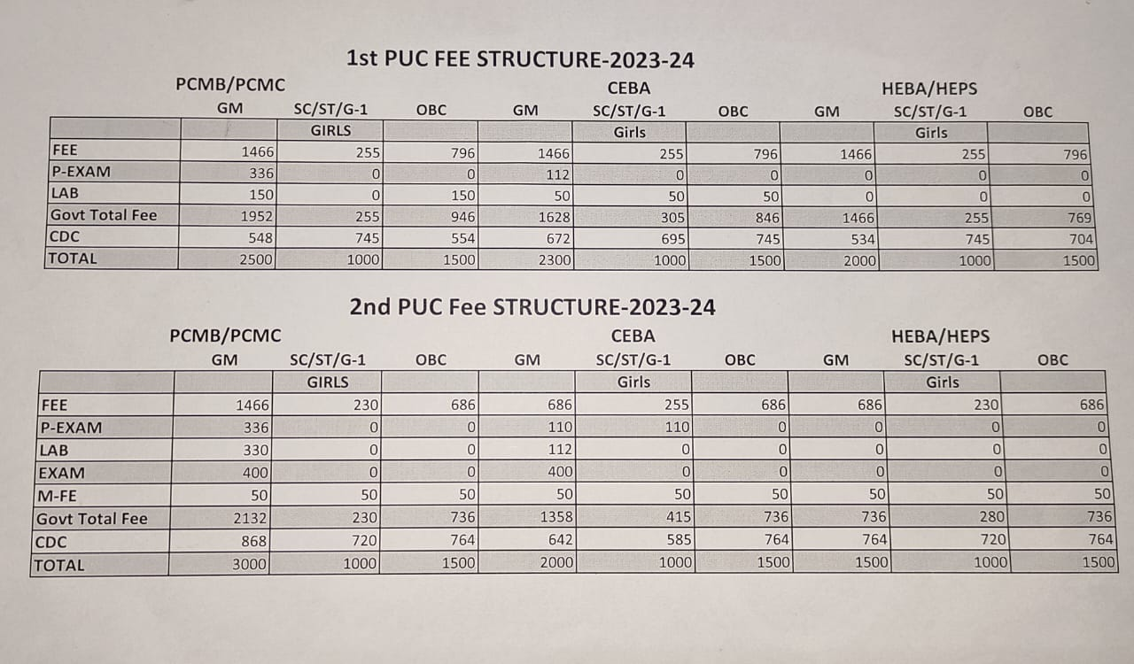

The Government Primary And HighSchool, Rajanakunte  
